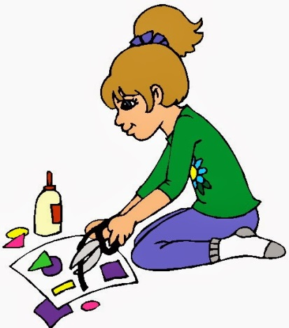

Makerspace
“All About Me”
Nametag

Background: Throughout the year, you will be getting to know your classmates AND we want to challenge your thinking in our Makerspace area. Your first project will be creating a nametag to introduce us to YOU and your interests.
Challenge Part 1: You will need to design a nametag that will stand up on its’ own and has at least one moving part. Your name will be displayed on it, as well as some “tidbits” about yourself and the scientist you are most excited to learn more about this year.
(***NOTE: Scientist choices will be listed on the Smartboard. You will need to research what each studies before choosing the one you will place on your nametag.)
Requirements:
*Must stand on its’ own for at least one minute.
*Your name needs to be large enough it can be read from 1 meter away.
*Nametag can be no larger than 6 in. high and 6 in. wide. It needs to be less than 2 in. in depth.
*Nametag must have at least one moving part.
*Name tag must be neat and include your personal information and favorite scientist.

Materials and Tools: You may use a combination of any of the following materials and tools to complete this challenge:
Construction paper, scrapbooking paper, newspaper, glue or glue sticks, tape, paper clips, craft sticks, straws, scissors, regular or colored pencils, rulers, crayons, markers, or a hole punch.
Challenge Part 2: Using your nametag, create a short stop motion or video that either explains your process of creation, what’s on your nametag or the scientist that you are most excited to find out more about. Videos can be 40-60 seconds long.

(***NOTE- For some classes this may be an optional project or is completed in the classroom at a later time.)

Have fun & be creative!!!



